# Mengyang Li Lab4 report

# P1

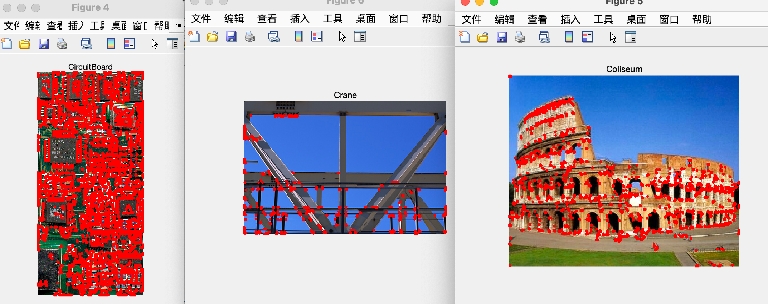

# P2

I have put the result( 4 videos) in the folder:

I did the challenge 1.

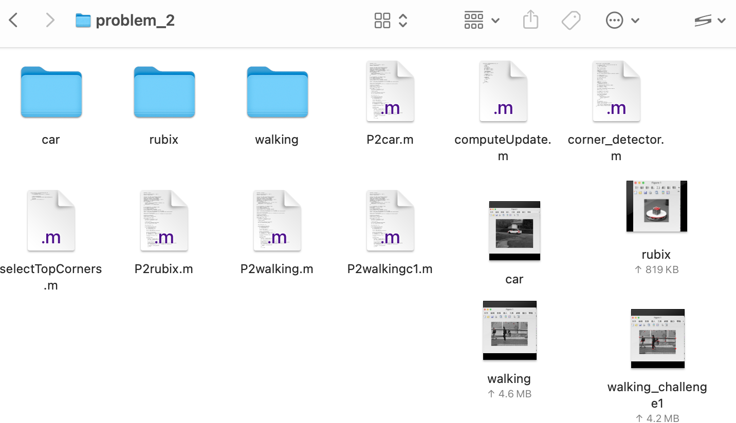

# P3

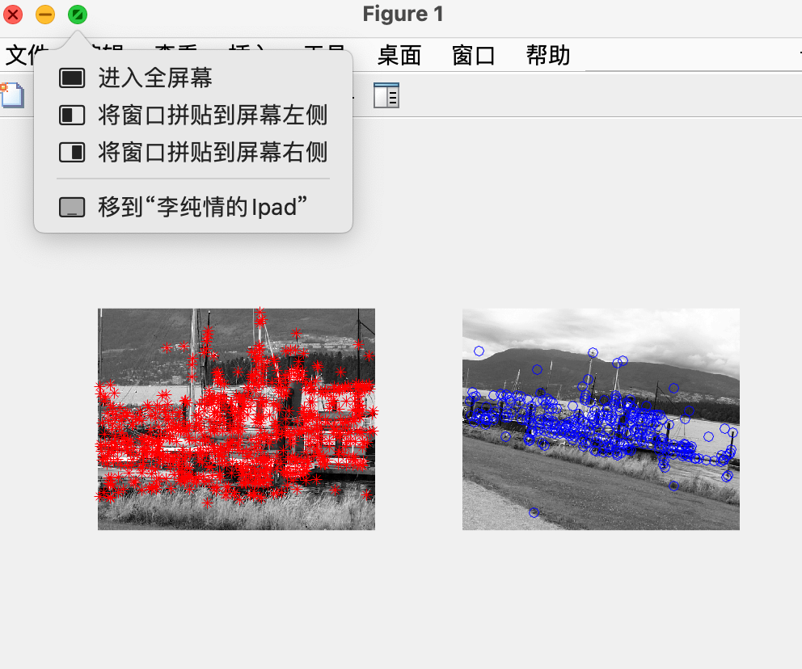

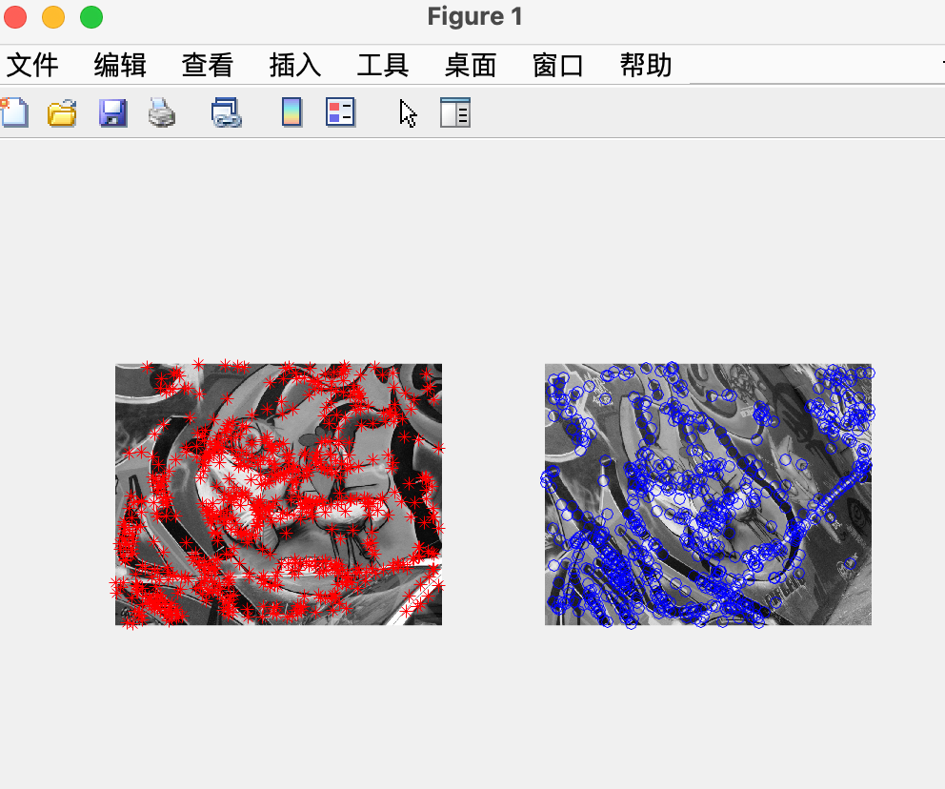

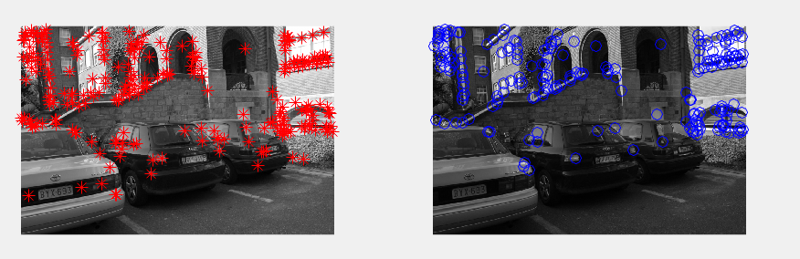

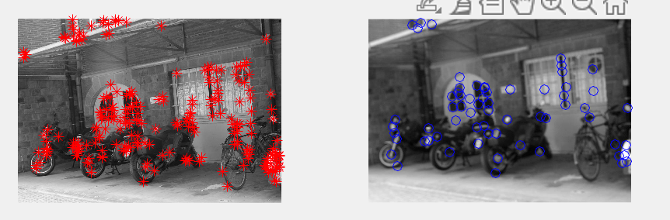

# P4

For the 1st set, corner detector is better.

By corner detector. Repeatability rate: 0.440297

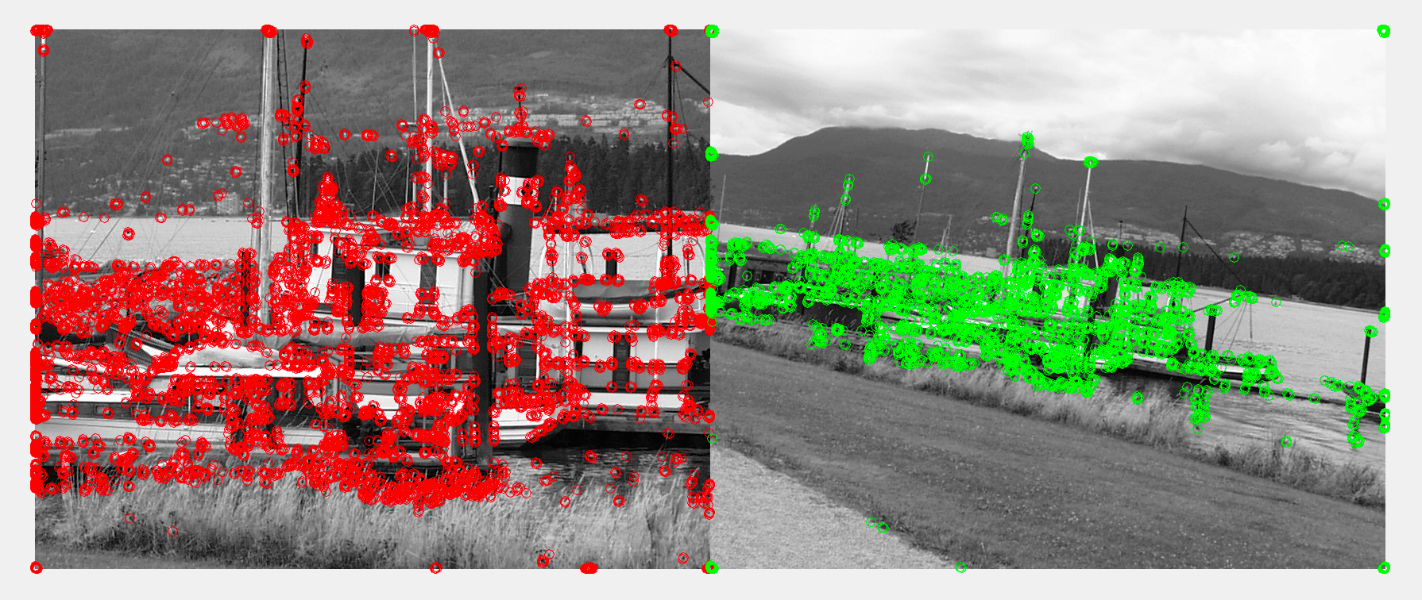

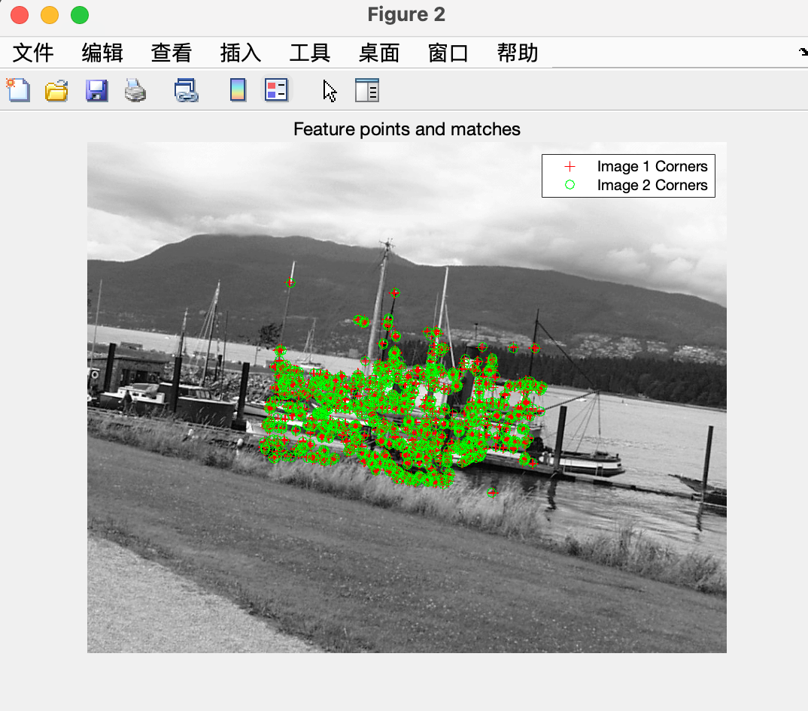

By SIFT. Repeatability rate: 0.174312

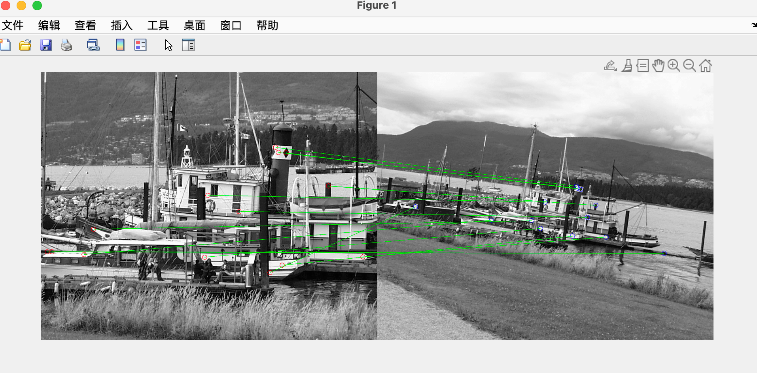

For the 2nd set, corner detector is better.

By corner detector. Repeatability rate: 0.404561

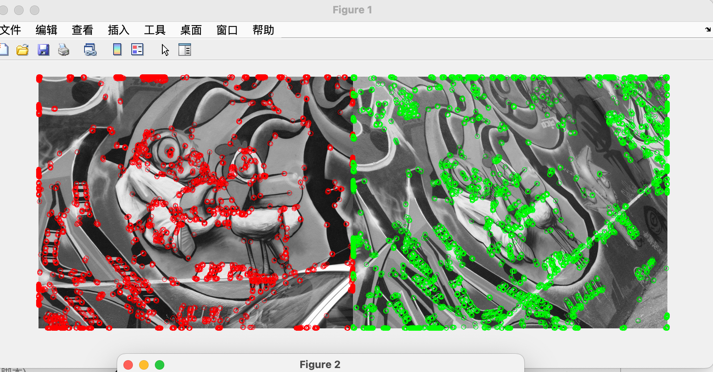

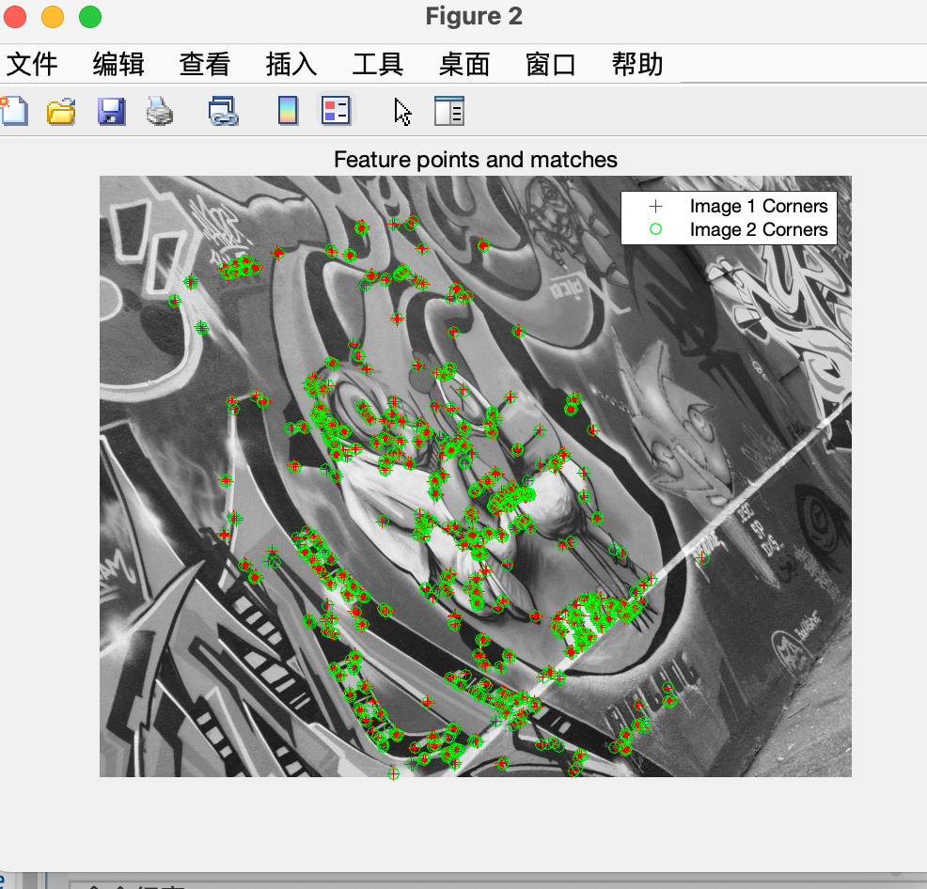

By SIFT. Repeatability rate: 0.086154

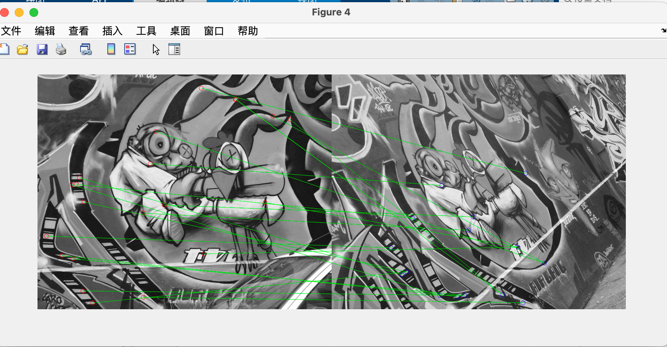

For the 3rd set, SIFT is better.

By corner detector. Repeatability rate: 0.273336

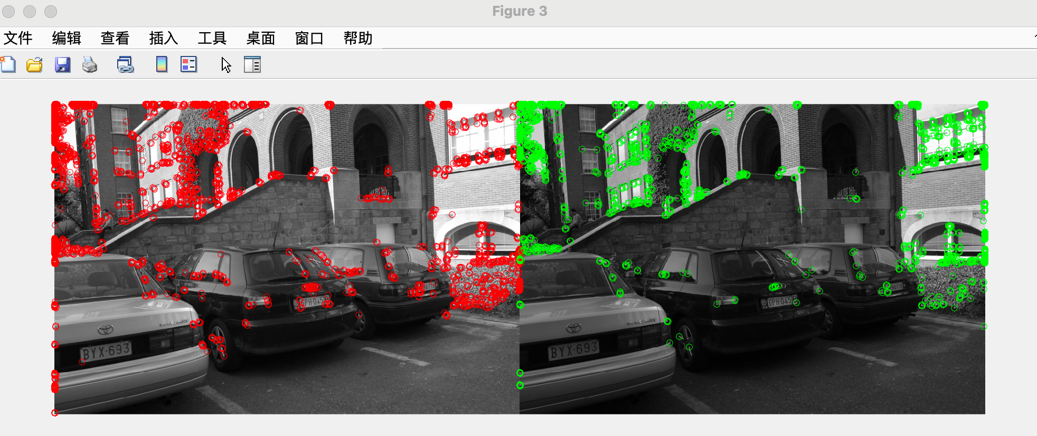

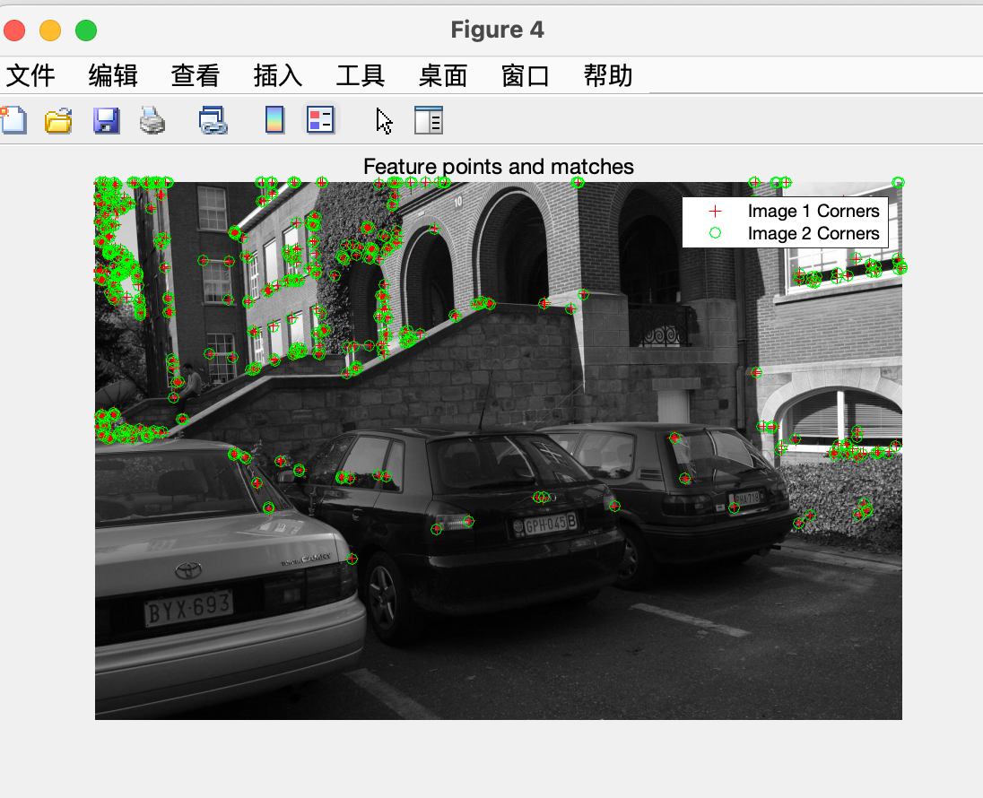

By SIFT. Repeatability rate: 0.75

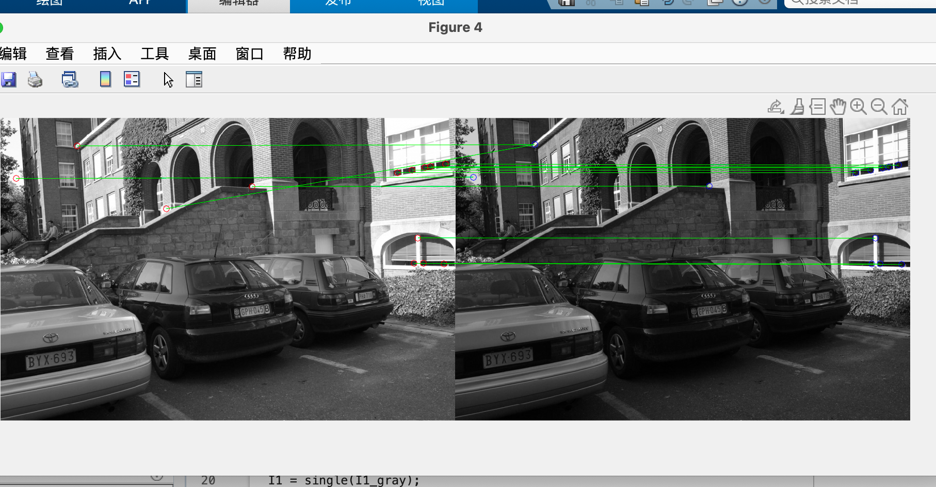

For the 4th set, SIFT is better.

By corner detector. Repeatability rate: 0.003840

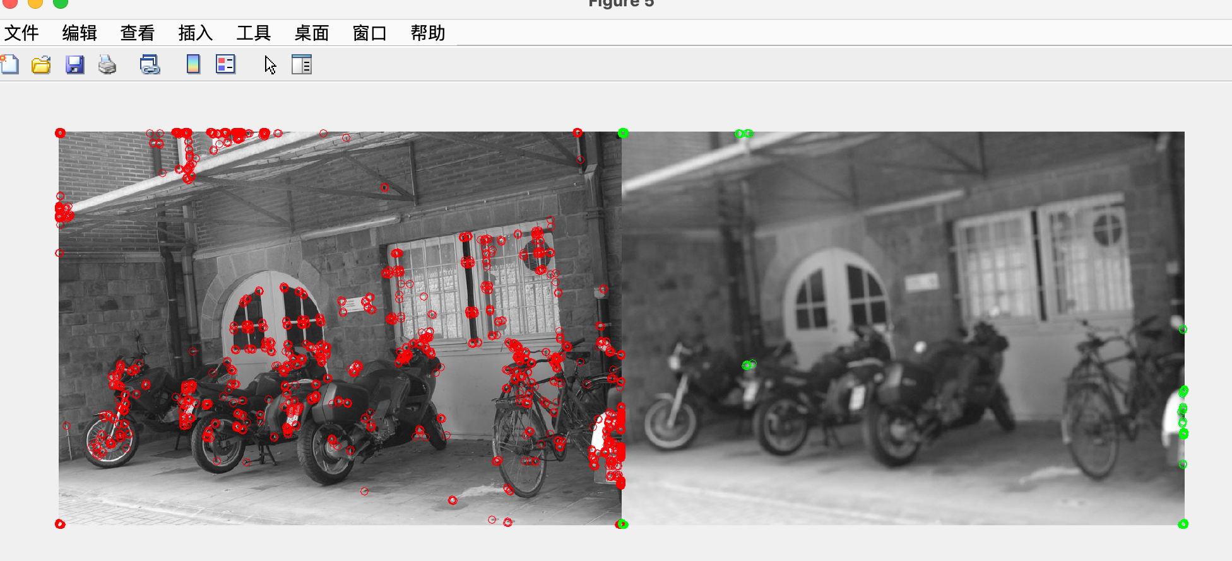

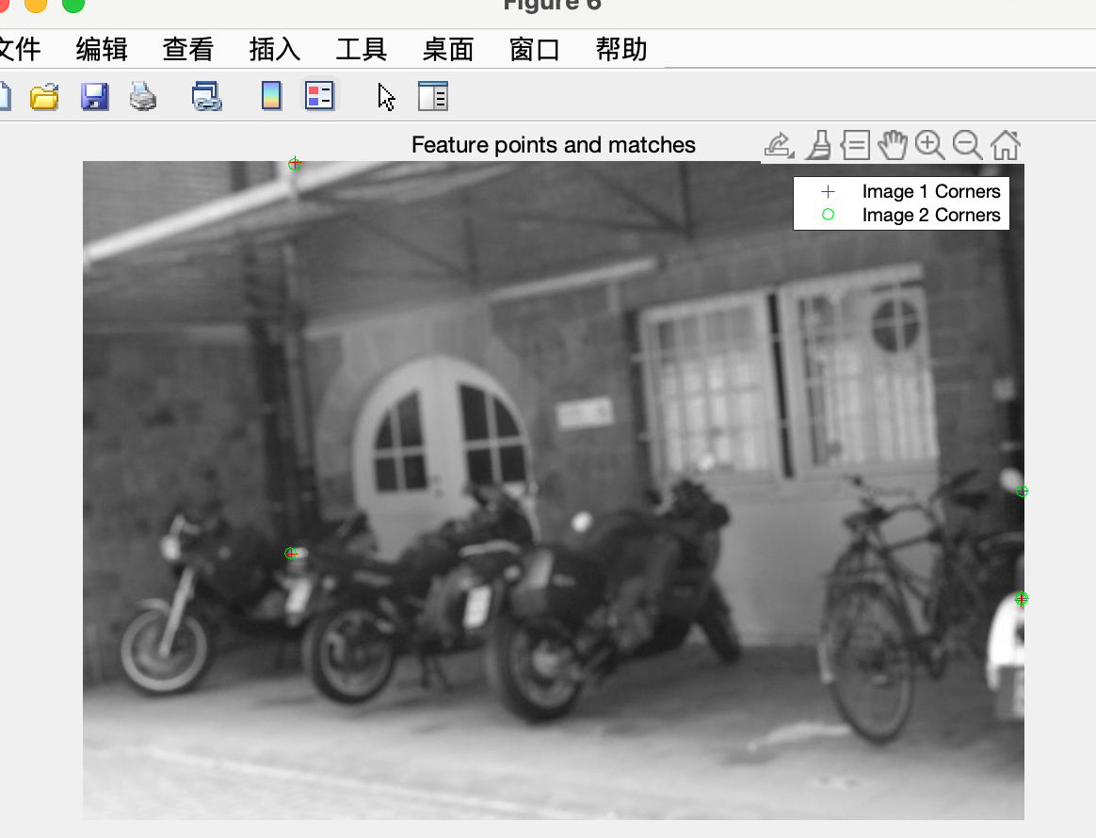

By SIFT. Repeatability rate: 0.311321

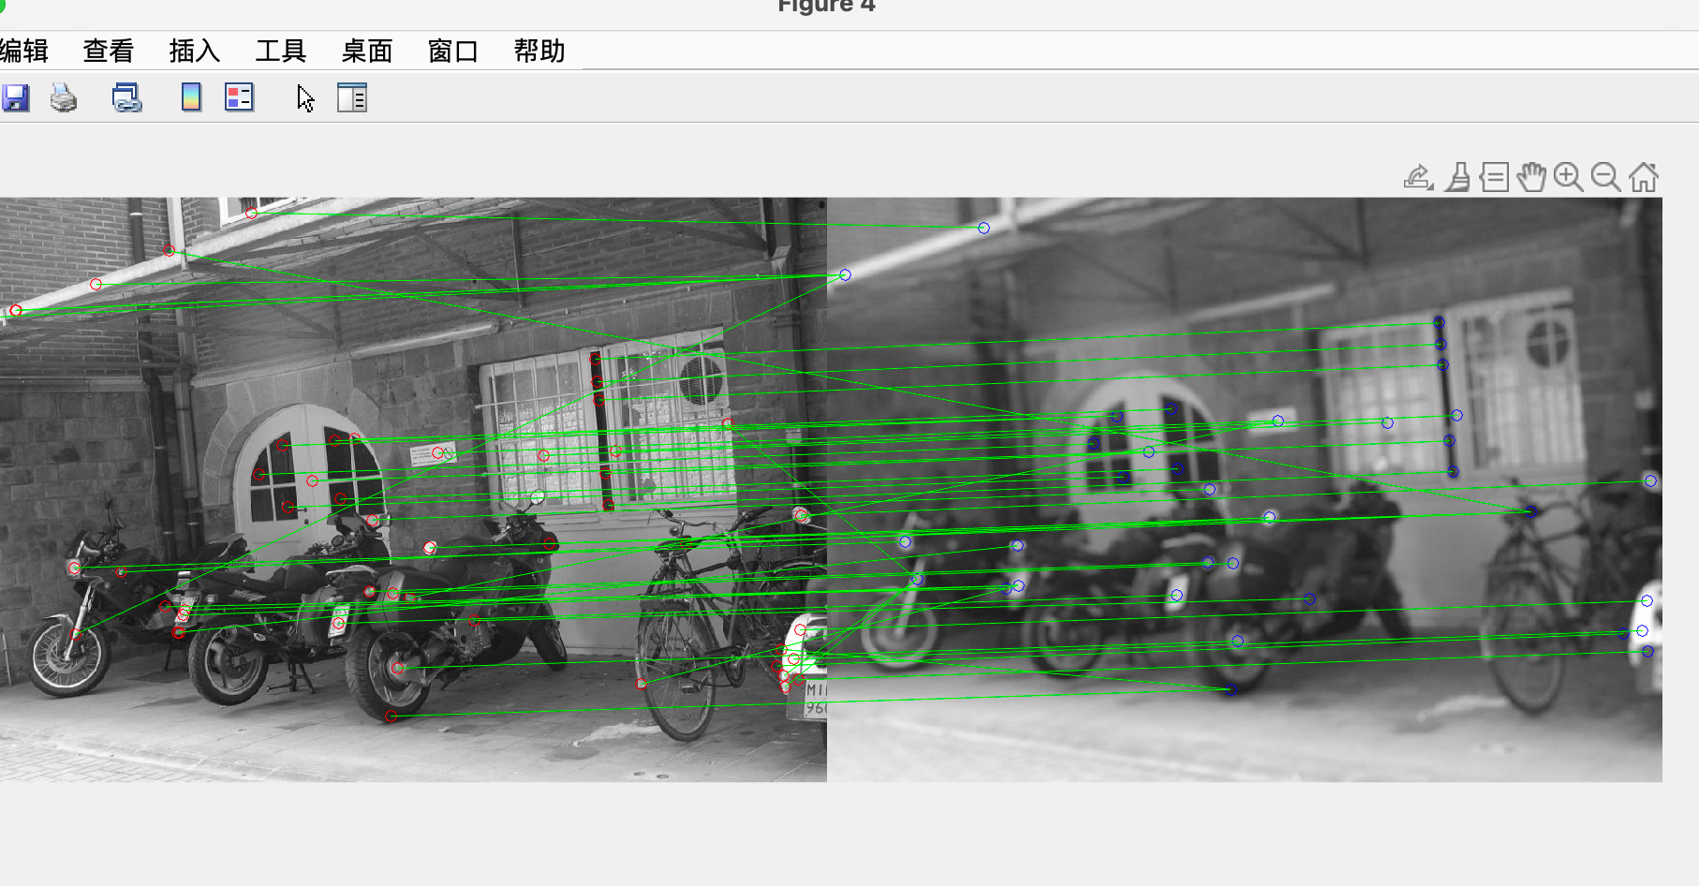

# P5

Which feature is easier to survive from all five images? Which feature generates more feature tracks?

Small translations or rotations are easier to survive.

Can you tell how the camera is moving based on the feature tracks?

From right to left.

Output by vl:

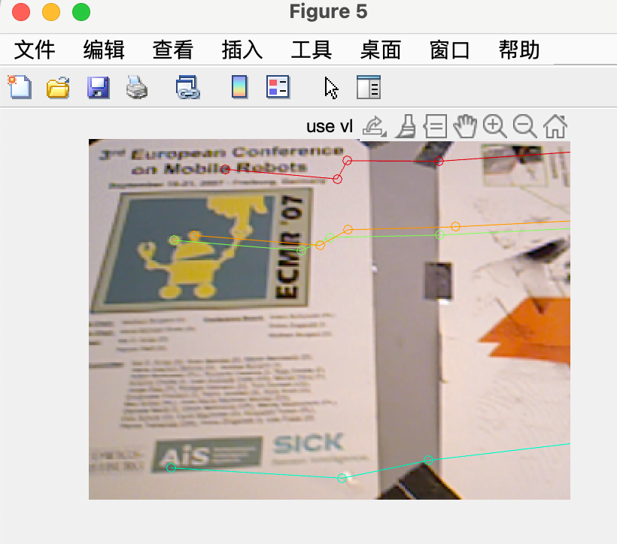

Output by corner detector:

